Introduction to Transaction Rules Solution

Exercise 1: Investigation

Create a **TransactionSetPresetup** rule called "Test Rule". Deactivate the rule. Then, follow the instructions and answer the questions.

1. For each question, you can retain or delete the code from the previous question.
2. Use the Studio syntax checker for assistance in fixing syntax problems.
3. Paste the following line of code into the **ACTION**. Is it syntactically well-formed? If not, what would you need to change to fix it? (Use the Studio syntax checker for hints.)

// Set TotalAmount to total amount of transaction set

var TotalAmount = transaction.ClaimAmount

Line 2 should be:

var TotalAmount = transactionSet.ClaimAmount

1. Paste the following line of code into the **ACTION**. Is it syntactically well-formed? If not, what would you need to change to fix it?

// Set NumberOfReserveTransactions to the number of reserve transactions

var NumberOfReserveTransactions = transactionSet.Reserves.length

Line 2 should be:

var NumberOfReserveTransactions = (transactionSet as ReserveSet).Reserves.length

1. Paste the following lines of code into the **ACTION**. Is it syntactically well-formed? If not, what would you need to change to fix it?

// Create ExceedsAvailableReserves. Set it to whether payments exceed reserves.

var ExceedsAvailableReserves : boolean

ExceedsAvailableReserves = transactionSet.ExceedsAvailableReserves

Line 3 should be:

ExceedsAvailableReserves = (transactionSet as CheckSet).ExceedsAvailableReserves

1. Paste the following lines of code into the **ACTION**. There are three syntactic errors. Correct the errors. (The comments describe what the code should do. Use the Studio syntax checker for hints.)

// For each transaction in transaction set, set amount equal to

// transaction amount. Then, if transaction is reserve transaction

// for reserve with Cost Category "salvage", add a note to the claim

for (txn in transactionSet.Transactions)

{

var amount = Transaction

if (txn.CostCategory == "salvage" AND txn is "Reserve")

{

txn.Claim.addNote( "salvage", "Salvage reserve created for " + amount )

}

next txn

}

Should be:

for (txn in transactionSet.Transactions)

{

var amount = txn.Amount

if ((txn.CostCategory == "salvage") && (txn.Subtype=="Reserve"))

{

txn.Claim.addNote( "salvage", "Salvage reserve created for " + amount )

}

~~next txn~~

}Exercise 2: Configuration

Configure ClaimCenter to meet the following customer requirement from Acme Insurance.

**Requirement 1: Recording Reserves in Notes** 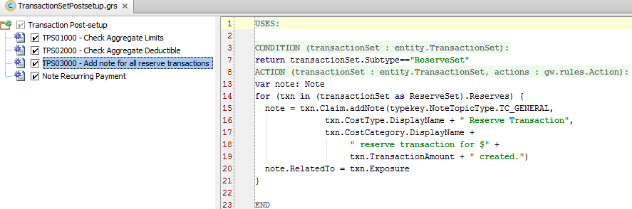

CONDITION:

return transactionSet.Subtype=="ReserveSet"

ACTION:

var note: Note

for (txn in (transactionSet as ReserveSet).Reserves) {

note = txn.Claim.addNote(typekey.NoteTopicType.TC_GENERAL,

txn.CostType.DisplayName + " Reserve Transaction",

txn.CostCategory.DisplayName +

" reserve transaction for $" +

txn.TransactionAmount + " created.")

note.RelatedTo = txn.Exposure

}Requirement 2: Payment Matching Reserve Fraud Detection

1. Given the customer requirements that this rule should fire whether or not the transaction is approved, this rule should be a pre-setup rule. Had it been a post-setup rule, it would only fire once the transaction was approved.

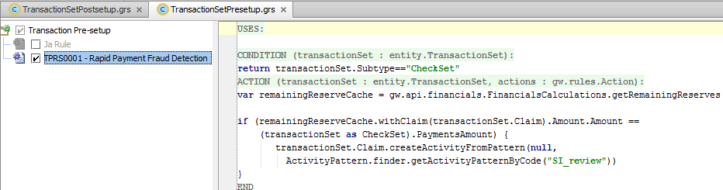

CONDITION:

return transactionSet.Subtype=="CheckSet"

ACTION:

var remainingReserveCache = gw.api.financials.FinancialsCalculations.getRemainingReserves()

if (remainingReserveCache.withClaim(transactionSet.Claim).**Amount.Amount** ==

    (transactionSet as CheckSet).PaymentsAmount) {

   transactionSet.Claim.createActivityFromPattern(null,   
 ActivityPattern.finder.getActivityPatternByCode("SI_review"))

}

Requirement 3: Assistance with Matter Creation

(Given the customer requirements, this rule should be a pre-setup rule. If you chose to get the CostType field from the ReserveLine, then it would need to be a post-setup rule, as the reserve line does not yet exist during pre-setup.)

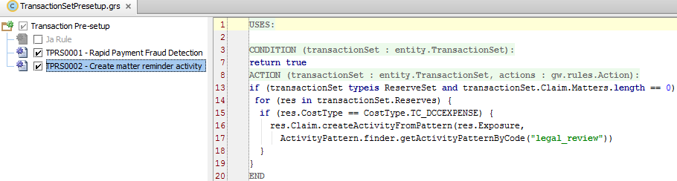

CONDITION:

return true

ACTION:

if (transactionSet typeis ReserveSet and transactionSet.Claim.Matters.length == 0)

for (res in transactionSet.Reserves) {

if (res.CostType == CostType.TC_DCCEXPENSE) {

res.Claim.createActivityFromPattern(res.Exposure,

ActivityPattern.finder.getActivityPatternByCode("legal_review"))

}

}